Q1)

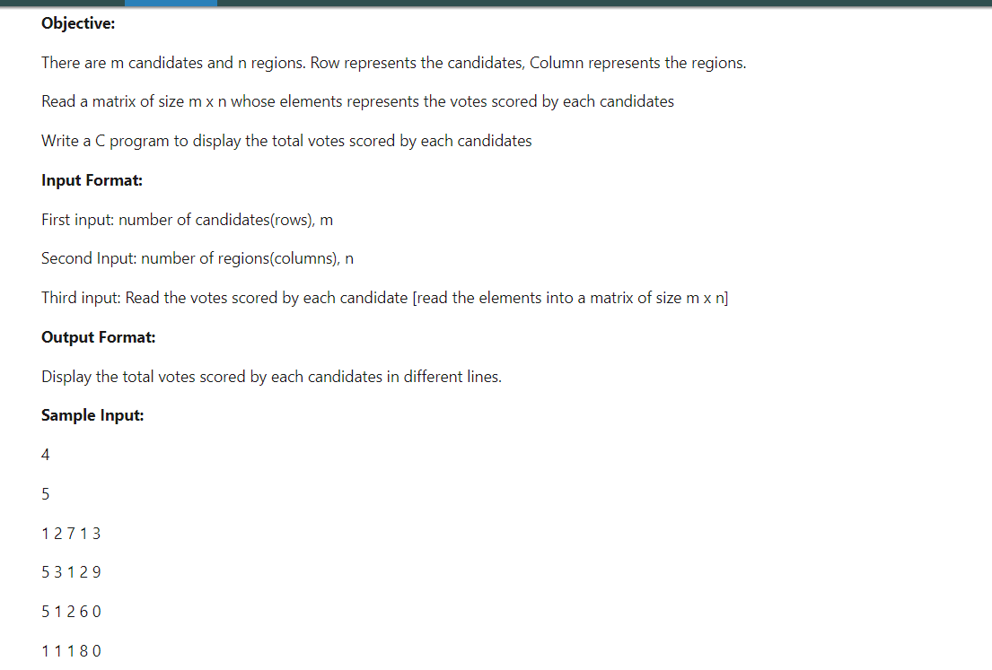

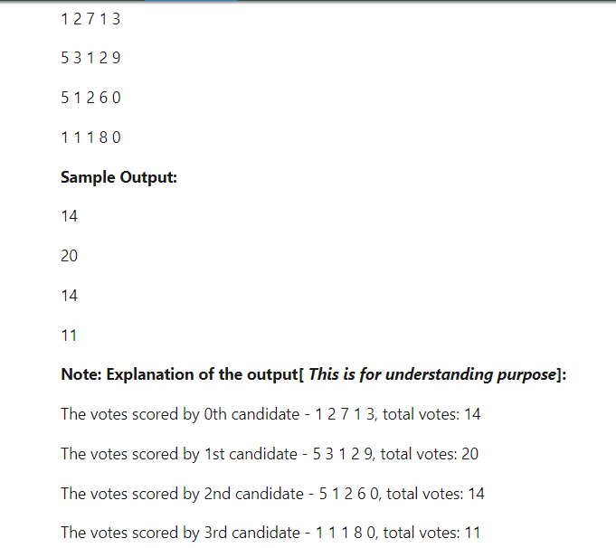

***#include*** <stdio.h>

**int** **main**()

{

**int** m,n,i,j,sum**=**0;

scanf("%d",**&**m);

scanf("%d",**&**n);

**int** a[m][n];

**for**(i**=**0;i**<**m;i**++**)

{

**for**(j**=**0;j**<**n;j**++**)

{

scanf("%d",**&**a[i][j]);

}

}

**for**(i**=**0;i**<**m;i**++**)

{

sum**=**0;

**for**(j**=**0;j**<**n;j**++**)

{

sum**=**sum**+**a[i][j];

}

printf("%d\n",sum);

}

}

Q2)

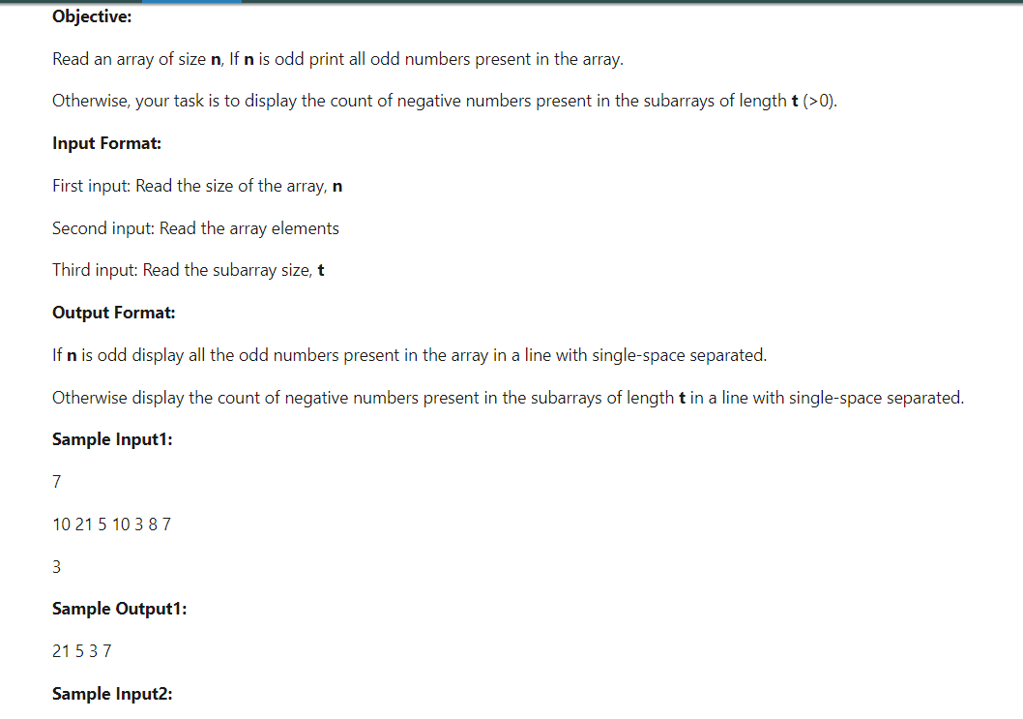

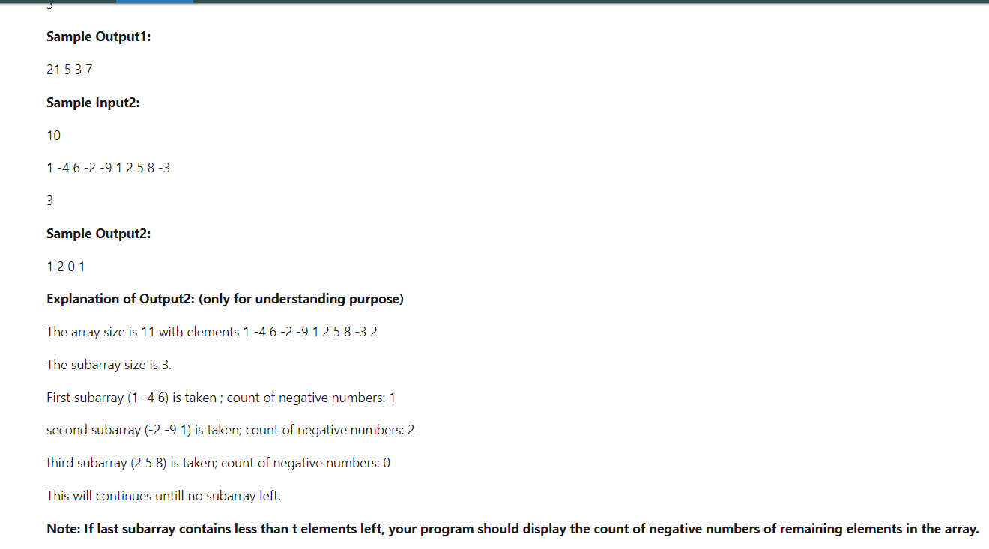

***#include*** <stdio.h>

**int** **main**()

{

**int** n,i,j,t,count**=**0;

scanf("%d",**&**n);

**int** a[n];

**for**(i**=**0;i**<**n;i**++**)

{

scanf("%d",**&**a[i]);

}

scanf("%d",**&**t);

**if**(n**%**2**!=**0)

{

**for**(i**=**0;i**<**n;i**++**)

{

**if**(a[i]**%**2**!=**0)

{

printf("%d ",a[i]);

}

}

}

**else**

{

**for**(i**=**0;i**<**n;i**=**i**+**t)

{

count**=**0;

**for**(j**=**i;j**<**i**+**t;j**++**)

{

**if**(a[j]**<**0)

{

count**=**count**+**1;

}

}

printf("%d ",count);

}

}

}